Sport-Tek ® PosiCharge ® RacerMesh ® Polo - $25.50
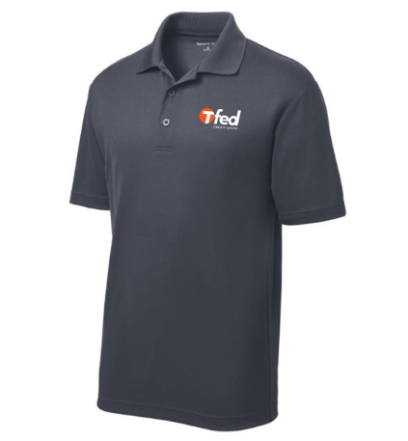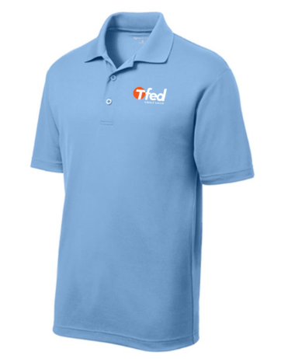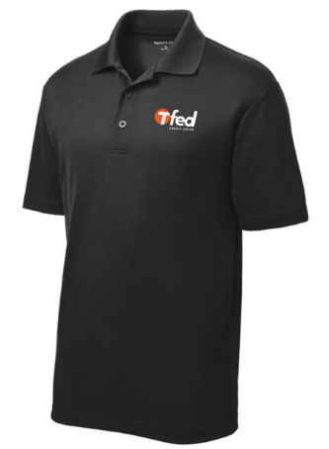
Dark Gray – Medium Light Blue – Large Black – Medium (x2)

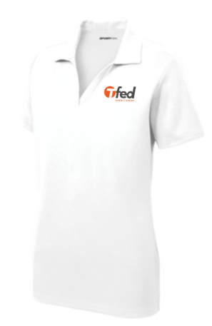
Sport-Tek ® Ladies PosiCharge ® RacerMesh ™ Polo - $25.50
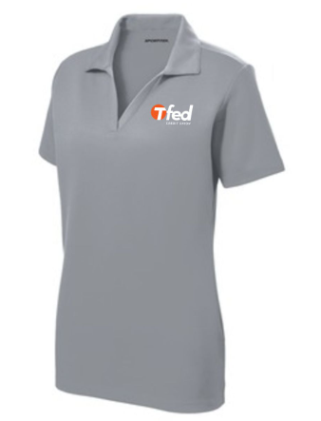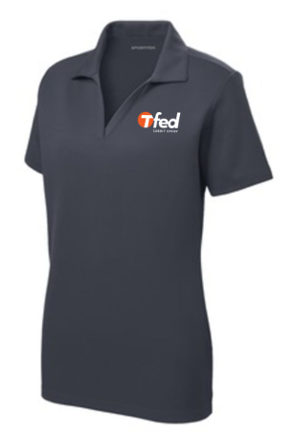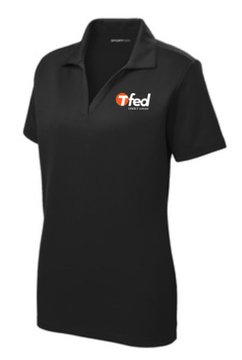
White – Medium (x2) Light Gray – Medium and Large Dark Gray – Medium Black – Medium

Sport-Tek ® PosiCharge ® RacerMesh ® Long Sleeve Polo - $27.75
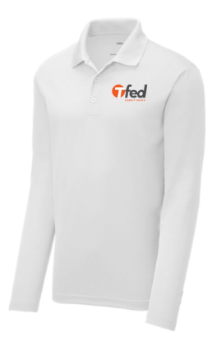
White – Medium

Cutter and Buck Clique Mens Helsa Half Zip Port Authority ® Women's Open-Front Cardigan Sweater
$57.75 $57.75
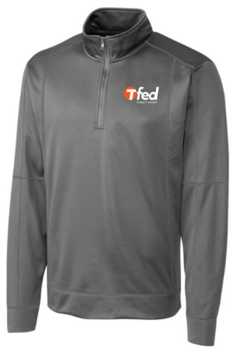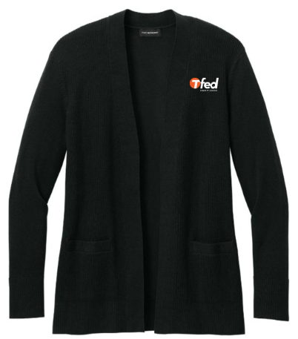
Dark Gray – XL (x2) Black – XL and XXL

Port Authority ® Ladies Torrent Waterproof Jacket
$62.25
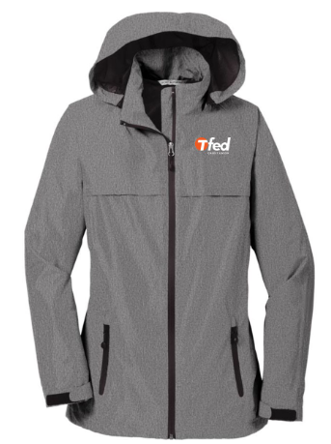
Dark Gray – Large

